Практические задания по дисциплине иностранный язык
для студентов группы 1 ПКД
на 07 апреля 2020 года
(работа рассчитана на 6 часов)

Тема "Витамины. Здоровое питание" (Healthy eating)

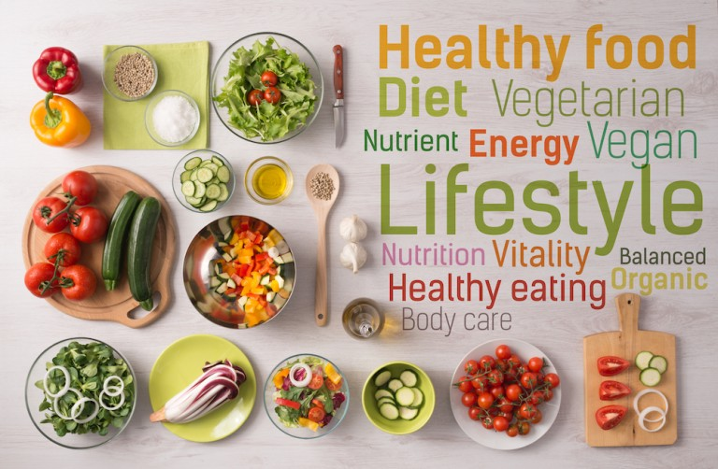

Задание 1. Запиши, прочитай и выучи лексику.

Vocabulary:
nutrient — питательное вещество
carbohydrate — углевод
protein — белок, протеин
fat — жир
to contain — содержать
to cut down on — зд, уменьшить прием чего-л.
to hide (past hid, p.p. hidden) — прятать, спрятать
crisp — ломкий, хрупкий
to get into the habit of — зд. взять за привычку
essential — существенный, жизненно важный
saturated fat — жиры с высоким содержанием насыщенных жирных кислот
butter — масло
unprocessed fat — необработанные жиры
seed — семя, семечко
avocado — авокадо, аллигаторова груша
tuna — тунец
additive — добавка
fertilizer — удобрение
pesticide — пестицид, ядохимикат
to increase — увеличить
to improve — улучшить
concern — интерес, участие, заинтересованное отношение
food chain — пищевая цепочка
to lead (past led, p.p. led) — вести, приводить
demand — потребность
modified food — модифицированная еда
rumour — молва, слух(и), слушок, толки
to cause — быть причиной, вызывать
cancer — рак (онкология)
fear — страх, боязнь, опасение
to solve — решать
to depend on — зависеть от
income — прибыль; заработок
lack — недостаток, нужда; отсутствие чего-л.
Жиры -fatlipids
белки - proteins and squirrels and protein and whites and
углеводы - carbs carbohydrates carbcarbohydrate

Жиры, белки и углеводы не были плохими или хорошими, просто были частью еды.
Fats, carbs, proteins - they weren't bad or good, they were food.

Задание 2. Прочитай и переведи текст. Выпиши слова по теме.

Vitamins are special substances that the body needs,along with proteins, fats, carbohydrates and minerals. Vitamin A is needed for healthy eyes and is found in fish-liver oil, eggs, yolk, butter, green vegetables and fruit. Vitamin D is needed for healthy bones and for protection against rickets. It is found in very small amount in egg,butter and fish. We get most of our vitamin D from the sun. Vitamin C protects against scurvy and is found in oranges,lemons,tomatoes,and green vegetables. Vitamin B is present in milk eggs, liver. It is needed to strengthen our nervous system.
The importance of vitamins for our health can hardly be overestimated. Probably, everyone has heard that vitamins and minerals are part and parcel of a healthy diet. Unfortunately, statistics says that today people all over the world consume too much calories and too little essential nutrients and vitamins. Lack of vitamins, known as vitamin deficiency, influences the state of our skin, hair, nails, teeth and bones. In more serious cases it can cause heavy diseases – spasms, loss of hair and teeth, loss of vision, hepatic disorders, skin diseases, and many others.
All in all, there are over thirty vitamins, and some of them are incorporated into groups. Vitamins themselves don’t have any nutritional value, in other words, they don’t contain any calories and can’t serve as sources of energy. They relate to micronutrients that are contained in food. So, to be healthy, we need to eat several types of food: fruit and vegetables, fish and meat, and milk products. Vitamins can be divided into two large groups: fat-soluble and water soluble ones. As the term suggests, water soluble vitamins are dissolved in water, while the fat-soluble ones are dissolved only in fats. The first group includes vitamin C and B-group vitamins. Such vitamins as A, E, D and K belong to the second group, and they can be stored in our organism. That’s why we lack vitamins of the first group more often.
The most essential vitamins for children are D, C and A. For example, vitamin D is responsible for the healthy development of bone tissues and teeth, as well as for calcium absorption. Its deficiency often causes rickets, which is especially dangerous for girls. People get it with sunshine, but if you live in the northern regions, where sunny days occur not very often, you should take enough D vitamins with food. It is contained, for example, in egg yolk, butter, cod liver oil. Babies get all vitamins with breast milk, so, breastfeeding women should eat these products. Vitamin A is responsible for the growth and good vision. It’s contained in beef liver. Greenery, carrots, tomatoes, and some other vegetables contain a lot of carotene, which if taken inside with any fat, is converted into vitamin A. As for vitamin C, it’s very important for the immune system. It can be found almost in all fresh fruit and vegetables, especially in kiwi, black currant, briar, and sweet pepper.

Задание 3. Прочитай, переведи и озаглавь текст.

Our health depends on our eating. Food provides us with the energy that we spend with physical exertion. Update and development of the organism at the cellular level directly depends on the products that we use. The body needs to receive a sufficient number of nutrients every day: proteins, carbohydrates, fats, vitamins, minerals, trace elements.
Proper nutrition is a mandatory point of a healthy lifestyle and a guarantee of stable functioning of the body as a whole.
Everyday diet should be diverse and full. Freshness of products is very important. It is necessary to monitor the volume of food intake. Each person's portion varies, depending on age, health status, gender, and equipment. Cereals, fruits and vegetables, fish, meat, eggs, dairy products, nuts, salt, sugar, fat, should be present in the diet. A balanced diet should become a way of life. You should refuse to give up snacks and fast food. Thoroughly chew food, do not swallow large chunks. It is strictly forbidden to drink food with water. You can eat everything, but in moderation. Overeating and incompatibility of products leads to a disruption of metabolism, diabetes and obesity. It is very appropriate to say Socrates: "We do not live in order to eat, but eat in order to live."

Задание 4. Прочитай, перескажи текст на русском языке. Ответь на вопросы после текста.
Healthy Food
All food is made up of nutrients which our bodies use. There are different kinds of nutrients: carbohydrates, proteins, fats» vitamins and minerals. Different foods contain different nutrients.
Before we cut down on fat, sugar and salt, we have to know a bit more about the kind of food these things might be in. The biggest problem comes when these things are hidden in other foods: biscuits, crisps, sausages, meat pies, soft drinks and so on.
The best way is to get into the habit of checking the ingredients and nutritional value on the sides of packets although this isn't always easy to do. Another thing to know is, for example, that we do need fat to live, it's an essential part of our diet and physically we couldn't exist without it.
But we all know that to eat much fat is bad for our health. The matter is that there are different kinds of fat. There are fats that are good for us and fats that are bad for us. Eating less of the bad ones and more of the good ones can actually help us to live longer! Bad fats are the saturated fats, found in animal productions, like red meat, butter and cheese.
Friendly fats are the unprocessed fats found naturally in foods like nuts and seeds, olives, avocados and oily fish, including tuna.
One more thing to know is that when food is cooked, its structure changes. It can change the vitamin and nutrient contents of food.
More and more people feel strongly about the way, their food is produced. Nowadays so much of the basic food we eat — meat, fish, fruit and vegetables — is grown using chemicals and additives.
Although fertilizers and pesticides have greatly increased the quantity of food and helped to improve its appearance, there is a growing concern about the effects of these chemicals in the food chain. This concern has led to a growth in the demand for organically grown products.
Today there is another problem. It is modified food, which is cheaper that ordinary one. There is a rumour that such food can cause cancer and other problems. Nobody knows, either it is just an imagined fear or a real problem. This problem could be solved and examined, but it will take some time.
The food we eat, depends on lots of things. Taste is a big factor. Culture, religion and health also play a part in what food we eat. Advertising and social factors also have a big influence.
Income is also an important factor. That is why not surprisingly, money, rather than a lack of knowledge about how to eat well, is at the heart of the problem.
Finally, there are three main messages to follow for healthy eating:
First, we should eat less fat, particularly saturated fat.
Secondly, we are to cut down on sugar and salt.
Thirdly, we must eat more fresh fruit and vegetables.

Questions:
1. What nutrients do you know?
2. What are the main things to know about food we eat?
3. What fats are good?
4. What fats are dangerous for our health?
5. What are the main factors that determine the food we eat?
6. What are three main messages to follow for healthy eating?

